Curve Tracer hardware manual
Diagram principle:
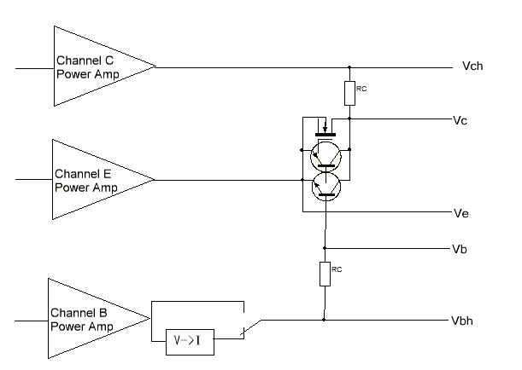
System have three channel power amplifier and drive the being test compent, and measure 5 vlotage(Vch/Vc/Ve/Vb/Vbh).
After get the Vch and Vc voltage then you can get the collect current(Ic).
After get the Vbh and Vb voltage then you can get the base current(Ib)..
After get the Vb and Ve, then you can get the Vbe /Vgs.
After get the Vc and Ve, then you can get the Vce /Vds.
You can change the B/C/E channel power amp output another voltage then you can measure the P or N type semiconductor. for example:
If you want measure a NPN BJT, you can set Channel E Power Amp to output 2.5V, and B channel is 5V, C channel is 20V. their polarity as below, then measure the Ve/Vbh/Vb/Vc/Vch then calculate the Vbe/Vce/Ib/Ic/Hfe. And change B channel output and get another Vbe/Vce/Ib/Ic/Hfe. When you get a sufficient amount of data, you can get the Ic-Hfe curve or Vce-Ic/Vbe-Ic curve .
If measure PNP BJT, You can set E channel output 36V, and set B channle output 30V, C channel output 5V, the current direction as below.
If measure N type J-FET, You can connect J-FET’s source to E, grid to B, drain to C. and set E channel output 10V,and set B Channel from 2.5V to 10V, and set C Channel output from 36V. This means that the J-FET’s Vgs is –7.5 to 0V, and Vds is +26V. This is the JFET normal operating voltage range.
The B channel additional “V-> I” module is suitable for measure Vce-Ic curve with constant base current.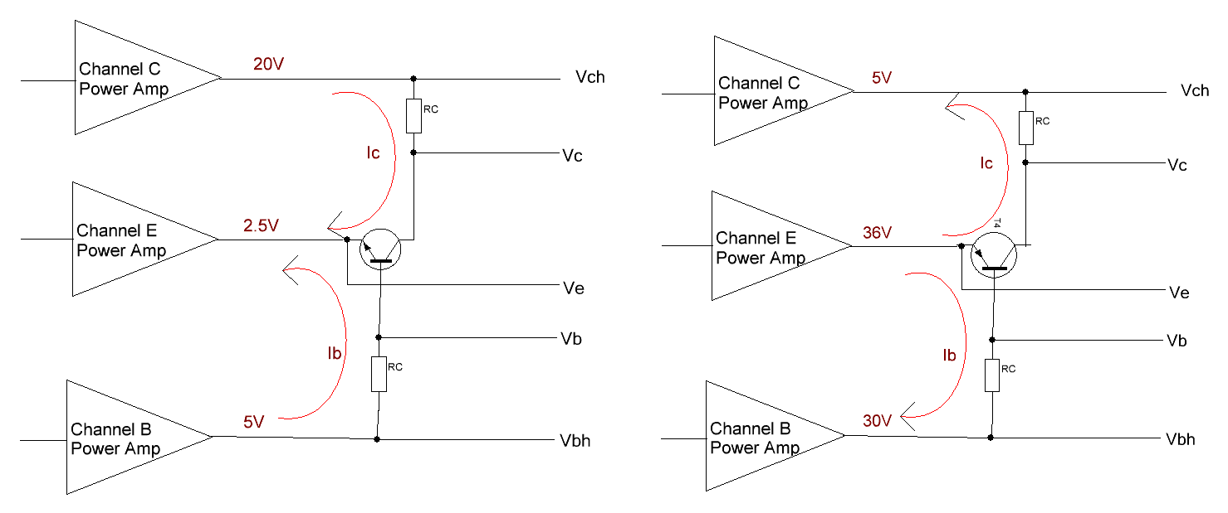
Actual circuit
1. Three channels power amplifiers
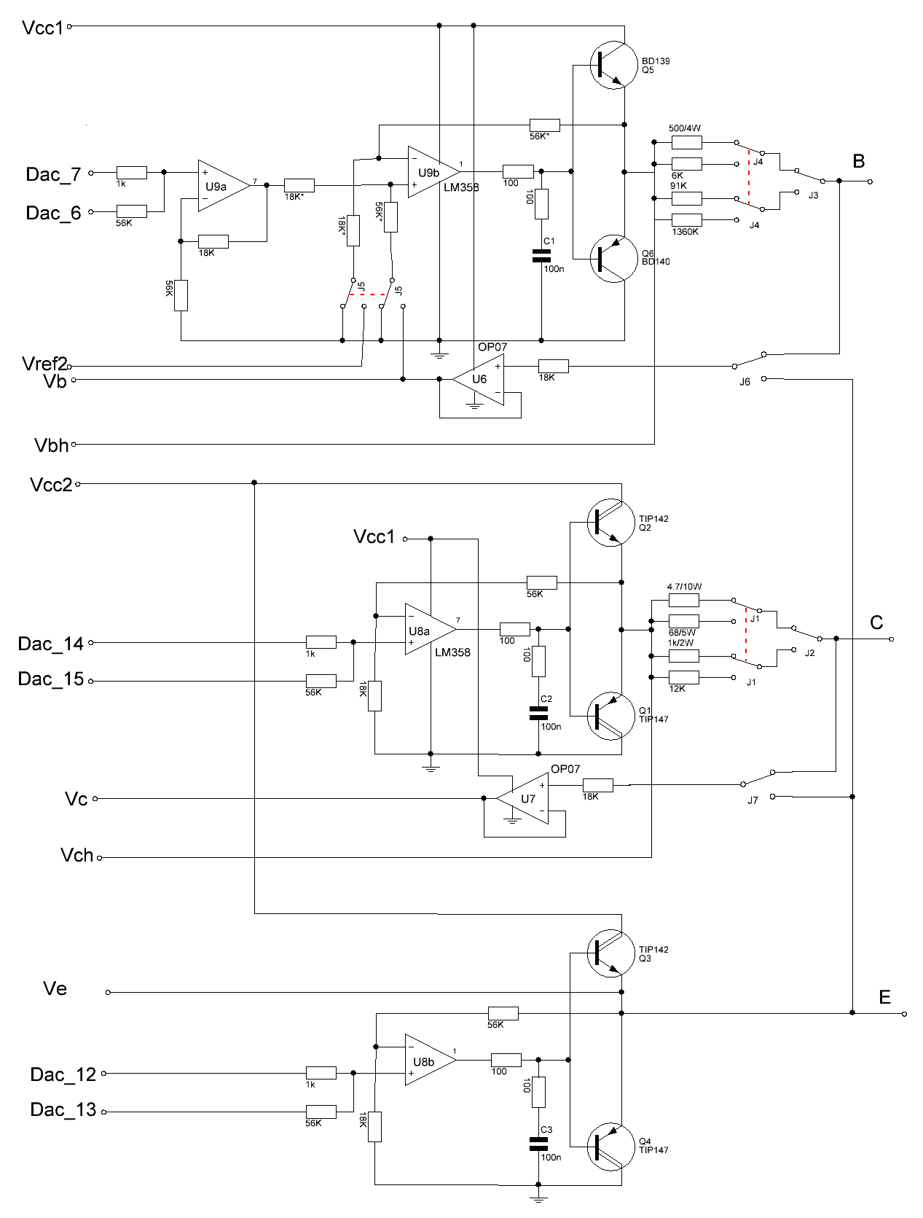

The B/C/E channel amplifier is the same, They all are operation amplifier (LM358) driver power transistor, They amplify the voltage from DAC. Because DAC just 8bit,So use two channel DAC combined into a high bit DAC with different resistor (56K/1K).
Because C/E channel need more current, so the C/E channel use high-current power Darlington.
In the C-channel output of the series with some resistor and relays. System by measuring the voltage drop across the resistor to get the collector current.
The U7 (OP07) as a DC follower, the purpose is to avoid diversion of the ADC input voltage divider resistors.
B channel have some complex, It add a relay J5 and Vref2, When J5 connect GND, The B channel is work as voltage amplifier; When J5 connect to U6/Vref2, the B channel is work as a bidirectional voltage-controlled current source.

2. power supply and protect circuit
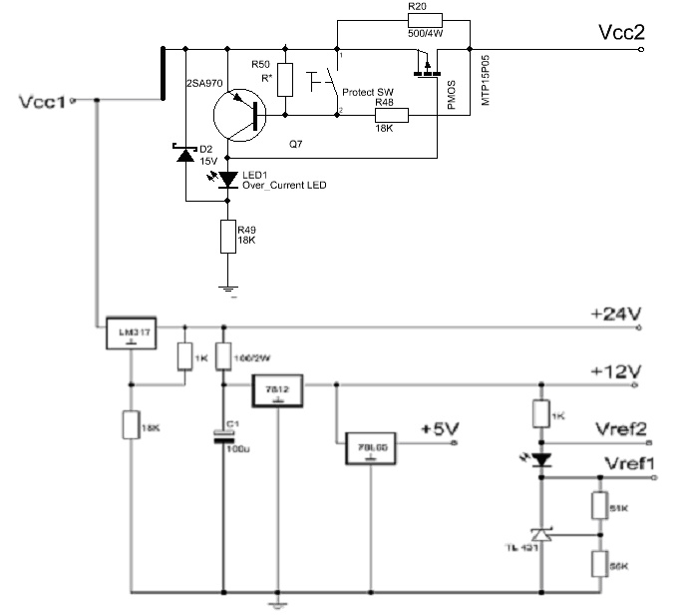
The Vcc2 have a over current-protect, the current more, then the voltage drop on PMOS is more, So 2SA970 turn on, and the Vgs of PMOS become less, PMOS become turn off, then the voltage drop is increate ,2SA970 more turn on, then PMOS is stop, So Vcc2 is stop.
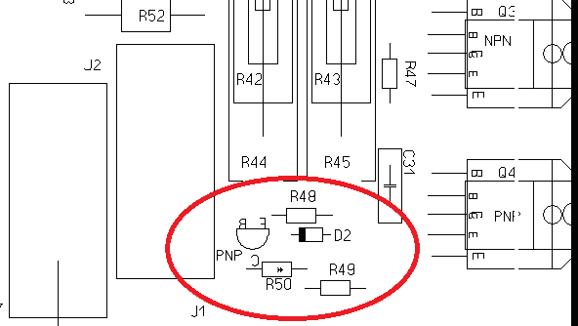
The sensitivity of the over-current protection is determined by D2 R48 R50 Q7 (2sa970) and PMOS internal resistance. Normal you can change the R50(R*) to adjustment the over-current.
The “Protect SW” had not installed, because once this button is depressed, the power amplifier will lose protection.

3. USB and RS232 interface circuits
The Max232 had removed and the “USB/RS232” toggle switch also had remove and been fixed at “USB”.
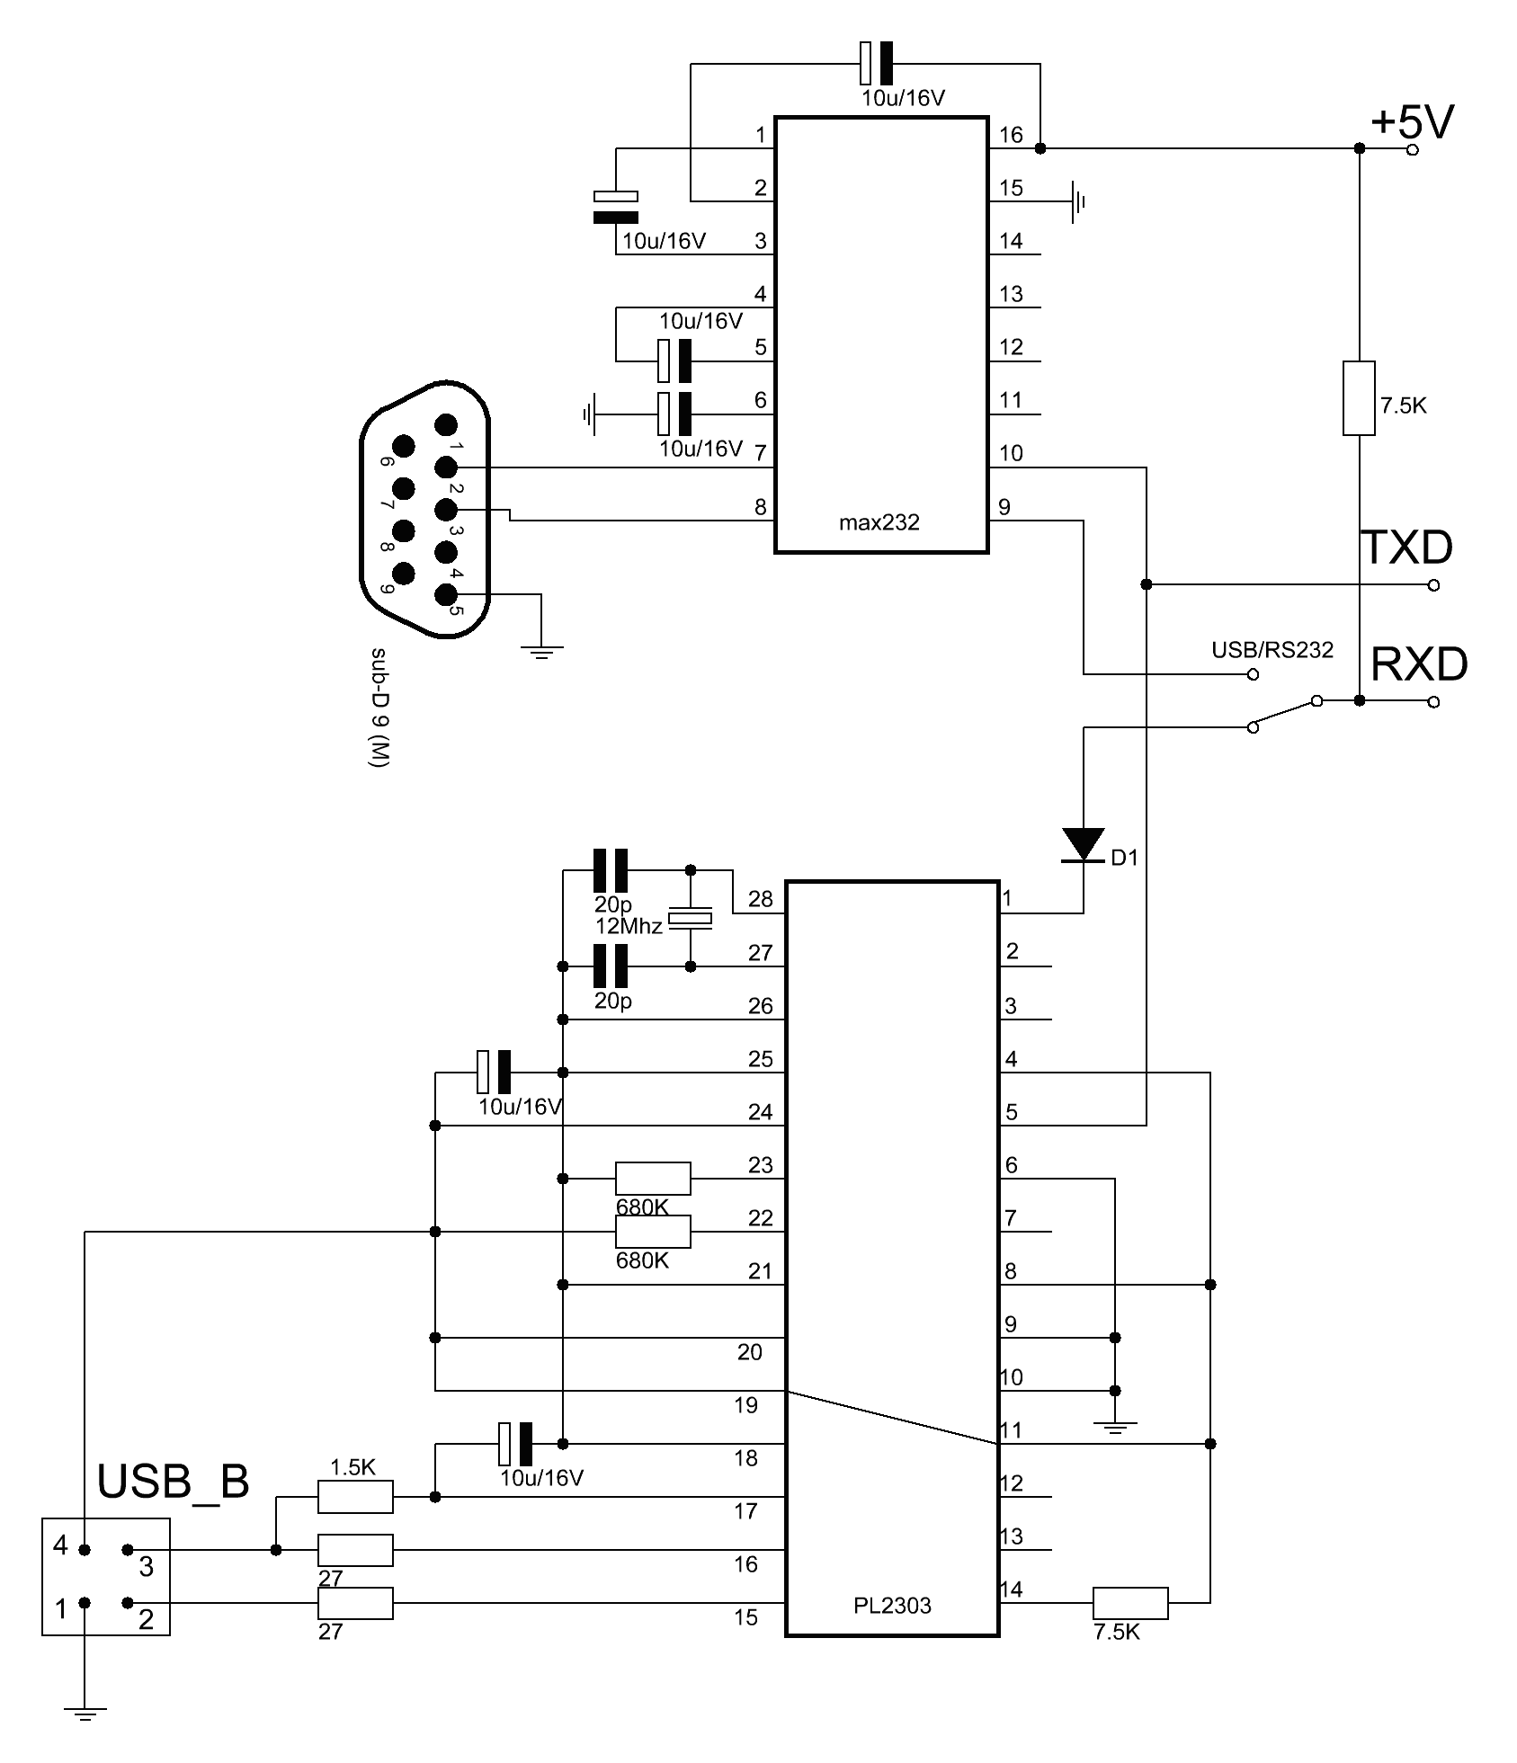
4.MCU & ADC & DAC & Control circuit
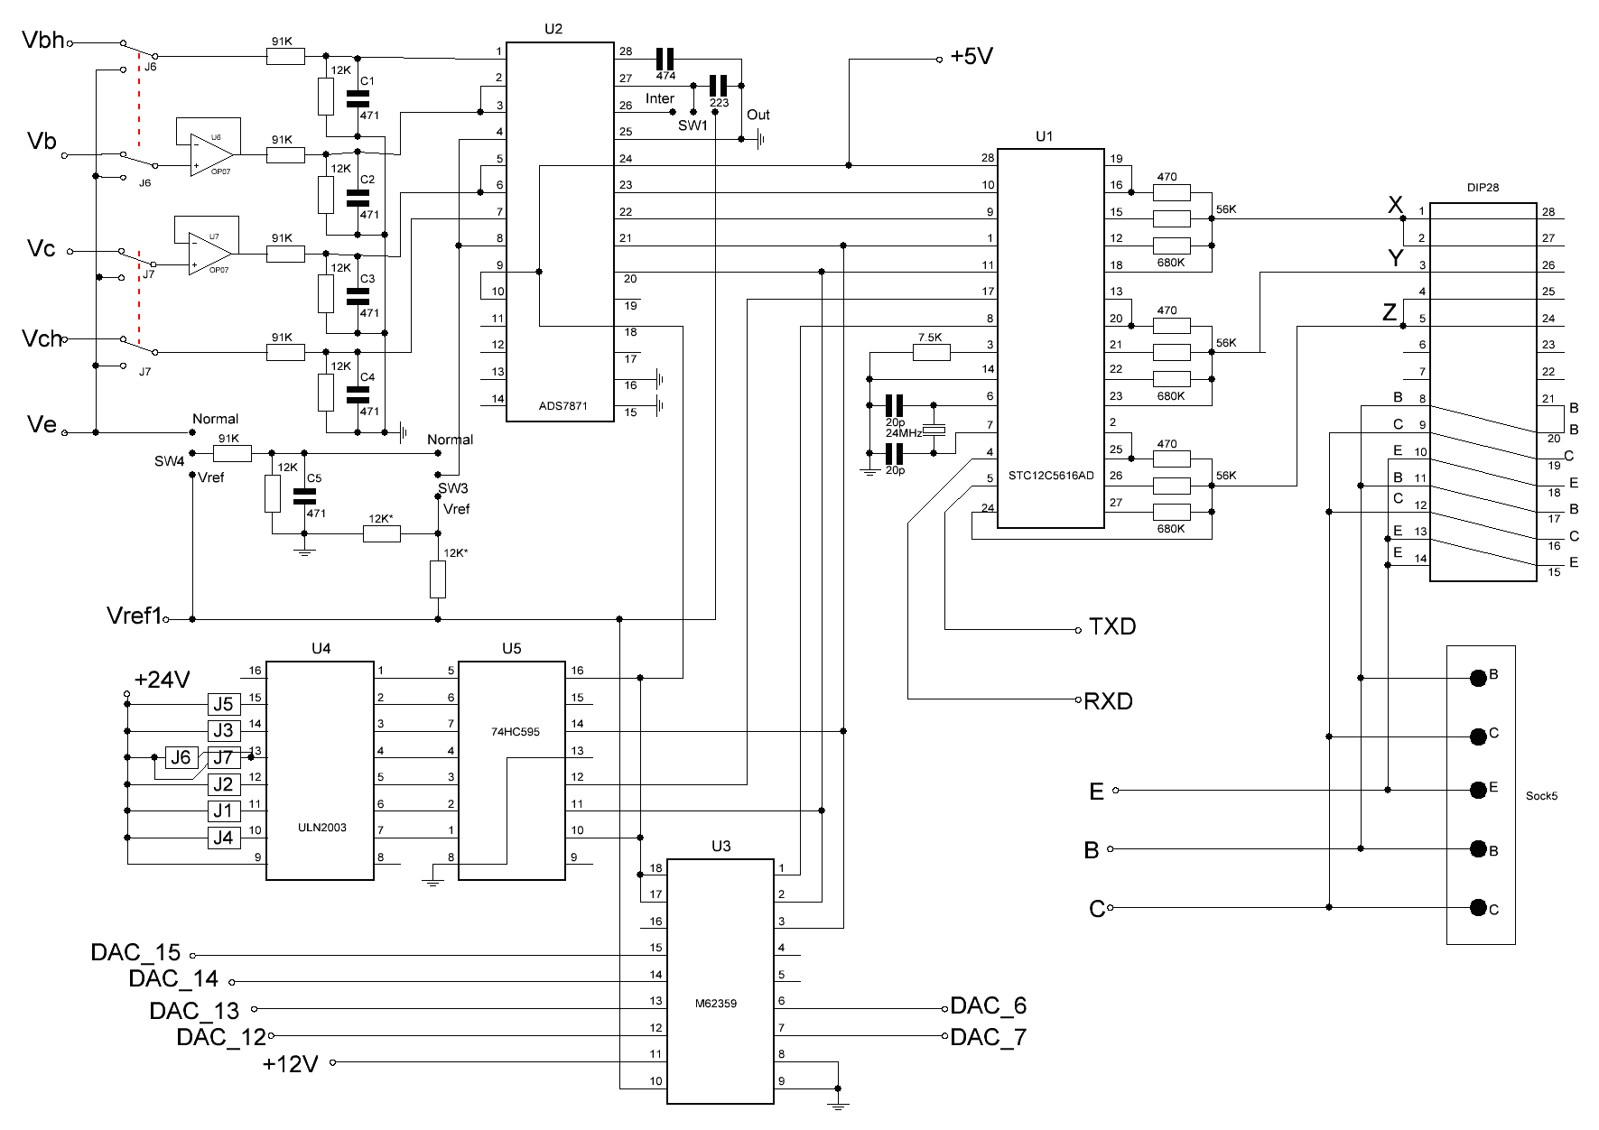
PCB
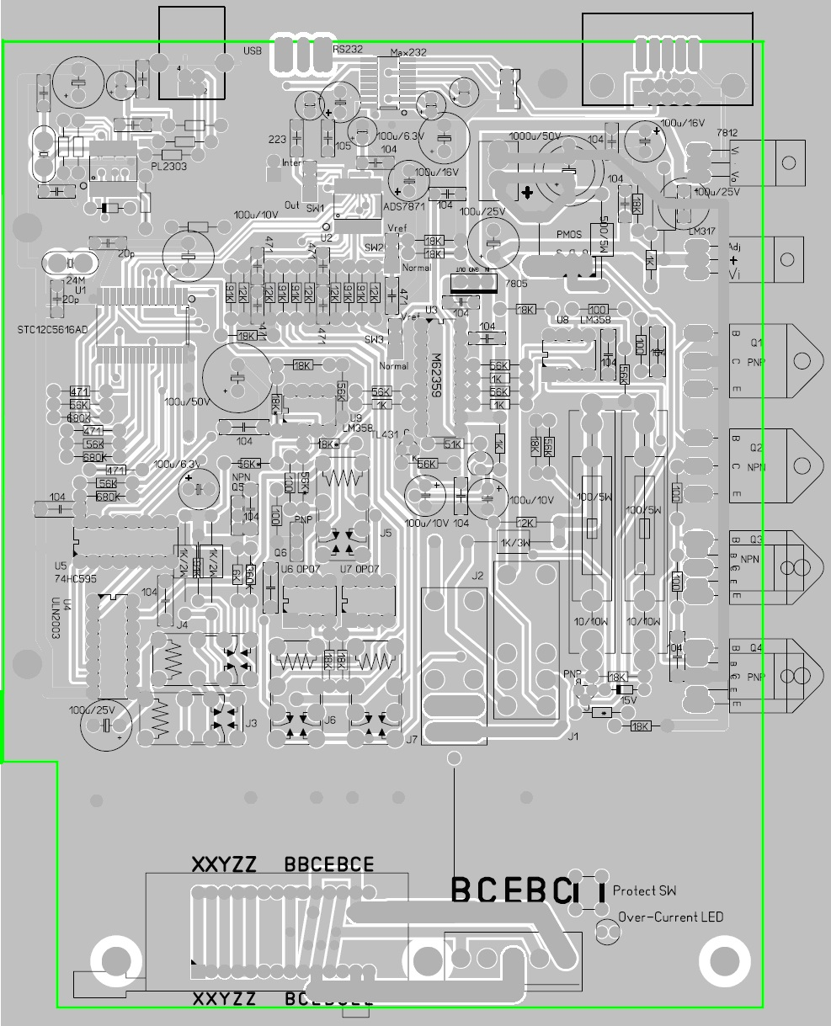
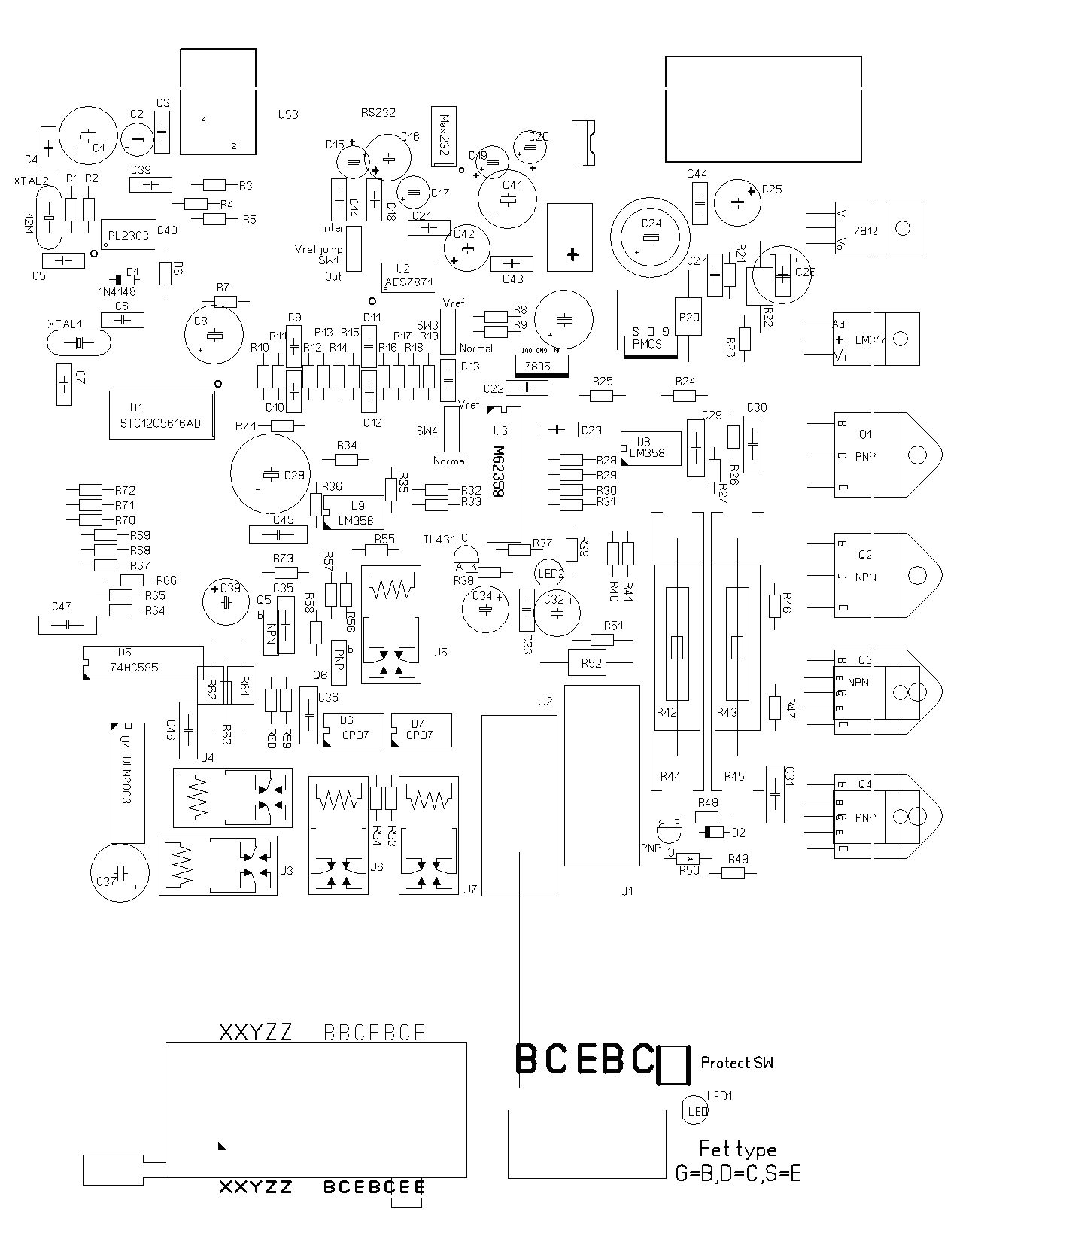

Compent List
C1 C2 = 100u/16V
C3 = 100n
C4 C5 C6 C7 = 20p
C8 = 100u/6.3V
C9 C10 C11 C12 C13 = 470p (220~560p)
C14 = 223 (103~473)
C15 C16 = 1u/16V
C17 = 100u/6.3V
C18 = 474 (224~105)
C19 C20 = 1u/16V
C21 C22 C23 = 100n
C24 = 1000u/50V
C25 = 100u/16V
C26 = 100u
C27 C28 = 100n
C29 = 1000u/50V
C30 C31 = 100n
C32 = 100u/16V
C33 = 100n
C34 = 100u/16V
C35 C36 = 100n
C37 = 100u/25V
C38 C41 = 100u/6.3V
C42 = 100u/16V
C43 C44 C45 = 100n
C46 = 100u/25V
C47 = 100n

D1 = 1N4148
D2 = 15V Zener

LED1 LED2 =

J1 J2 = Ormon G2R-2 24V 5A
J3 J4 J5 J6 J7= Ormon G5V-2 24V 0.3A

PMOS = MTP15P05 (>5A >50V Rds<0.3ohm PMOS)

Q1 = TIP147(>5A >50V >65W PNP Darlington) TO-3P
Q2 = TIP142(>5A >50V >65W NPN Darlington) TO-3P
Q3 = TIP142(>5A >50V >65W NPN Darlington) TO220 or To-3P
Q4 = TIP147(>5A >50V >65W PNP Darlington) To220 or To-3P

Q5 = BD139(>1A >50V >10W NPN) To126
Q6 = BD140(>1A >50V >10W PNP) To126
Q7 = 2SA970(>0.1A >50V PNP) To92

R1 R2 = 680K (4.7K~820K)
R3 = 1.5K
R4 R5 = 27 (22~100)
R6 = 680K (4.7K~820K)
R7 = 7.5K (2.2K~8.2K)
R8 R9 = 12K (10K~20K, they must match )
R10 R13 R14 R17 R18 = 91K low temperature drift
R11 R12 R15 R16 R19 = 12K low temperature drift
R20 = 500/4W (I use two 1Kohm 2W parallel)
R21 = 18K
R22 = 100/2W (47~130 2W)
R23 = 1K
R24 = 100
R25 = 18K
R26 = 100
R27 = 56K
R28 R30 R32 = 1k
R29 R29 R31 R33= 56K
R34 = 18K
R35 = 56K
R36 = 18K
R37 = 51K ( I use 56K and 680K parallel)
R38 = 56K
R39 = 1K (1K~1.8K)
R40 = 18K
R41 = 56K
R42//R43 = 75/10W (current sample Resistor RC1 56~75 10W , R42 R43 I use two 150ohm 5W parallel)
R44//R45 = 4.55/20W(current sample Resistor RC0 4.1~6.8 20W , R44 R45 I use two 9.1ohm 10W parallel), Over R42 R43
R46 = 100
R47 = 100
R48 = 18K
R49 = 18K
R50 = Adjustment over current protection,
R51 = 12K(Current sample Resistor RC3 10K~15K)
R52 = 1k/2W(Current sample Resistor RC2 820~1.2K 2~5W)
R53 R54 R55 = 18K
R56 = 56K
R57 R58 = 100
R59 = 1360K (current sample resistor RB3 1M ~ 1.5M, I use two 680K in series)
R60 = 6K(current sample resistor RB1 5～9K, I use two 12K in parallel)
R63 = 91K(current sample resistor RB2 68～120K)
R61//R62 = 500/4W (current sample resistor RB0, R61 & R62 I use 1K 2W and parallel to 500ohm 4W)
R64 R67 R70 = 680K(470K~680K)
R65 R68 R71 = 56K(39K~68K)
R66 R69 R72 = 470(390~560)
R73 = 56K
R74 = 7.5K

U1 = STC12C5616AD or STC12C5612AD sop28
U2 = ADS7871 ssop28
U3 = M62359 DIP18
U4 = ULN2003 DIP16
U5 = 74HC595 DIP16
U6 U7 = OP07 DIP8
U8 U9 = LM358 DIP8 Single supply OP, LM358 manual said maximum power 32V, in fact 40V power supply is also no problem,but you can use LT1013 replace .
= max232 sop16
= PL2303 ssop28
VR2 = 7812 to220
VR3 = 78L05 or 7805 To92 or To220
VR4 = LM317 to220
D =TL431 To92

XTAL1 = 24MHz
XTAL2 = 12Mhz

USB/RS232 = Toggle switch
= sub-D 9 (M) DB9

Curve Tracer Diagnosis
The following diagnosis is based on the USB interface mode.(USB/RS232 toggle switch is switched to USB).

1.USB interface is OK?
On PCB,the USB chipset PL2303 is powered by the external PC USB supply, that is, even if the tracer is not powered on, so long as the USB port is plug in, the USB interface will work, and from the device manager of Windows, you can find the “Prolific USB-to-Series Comm Port(COM X)”.
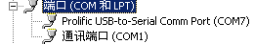
If no this device, Maybe pl2303 chipset is wrong or USB cable wrong.
If you are run under Windows 8, The newest pl2303 driver not compatible it, you must install the 1.50 version driver. Under Windows 8 to install old version of pl2303 driver can be found on the Internet.
If you can find the “prolific USB to Series Comm port” then the interface is OK.

2. Board is normal?
Use some wire to short three terminals (X-Y-Z) of the measurement socket same time, then, turn on power. You should hear 8 to 9 relay click sound, it indicates the MCU is working, It mean 24V & 5V power supply is normal, 74HC595 and ULN2003 are also working normal.
If you do not hear the relay clicks sound, please check the 24V(LM317 output), 5V(78L05 output) power supply, 74HC595, ULN2003 chip.

3. Communication is OK?
Run the program, select the menu “Options -> config”, click on “Auto detect & get parameter” button.
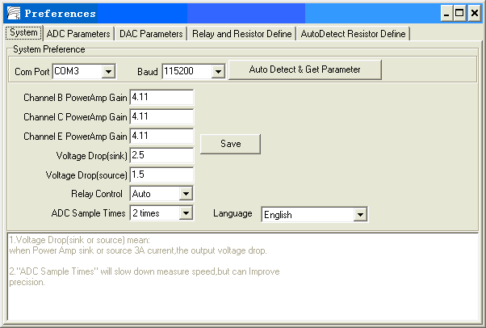
If you get “Parameter have get from Device” - means communication is OK, and the parameters in board load into PC successfully.
If you get “Parameter in EEPROM have some Error!” – means the board not calibration or parameter in board have wrong. You need to configure the EEPROM parameters manually. Please refer to “Config & Calibration”.
If you received “device not found” – If step 1 & 2 is OK and toggle switch is USB, but just get “device not found”,It maybe PL2303 chip or USB cable not good.

4. Check the relay is OK?
Run program select menu “Options->Config” select page “Relay and Resistor Define”,
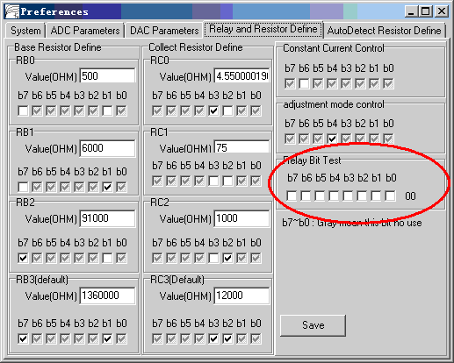
The groupbox of “Realy Bit Test” to test the relay. Normaly only b7/b6/b4/b3/b2/b1 control relay, b5/B- no use.
You can check and uncheck them, you can hear the relay sound, mean the 74HC595/ULN2003 and relay is OK.

5.Check the power amplifier output OK?
Run program, select menu “Options->Diagnosis”. If board communication OK, all button is not gray,they all enable.
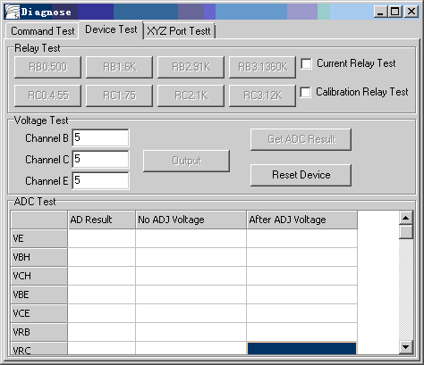
The “Channel B/Channel C/Channel E” label to setting B/C/E channel power amplifier output, their range is (2~36)V, and click “output” button to apply amplifier output.
The “Get ADC result” button to measure 7 channels voltage: VE/VBH/VCH/VBE/VCE/VRB/VRC. The 7 channels voltage described as below figure.
The 8 buttons “RB0:500” ~ “RC3:12K” control the RB/RC select relay.
Don’t check on the “Current Relay Test” and “Calibration Relay Test”. They function to be described later.
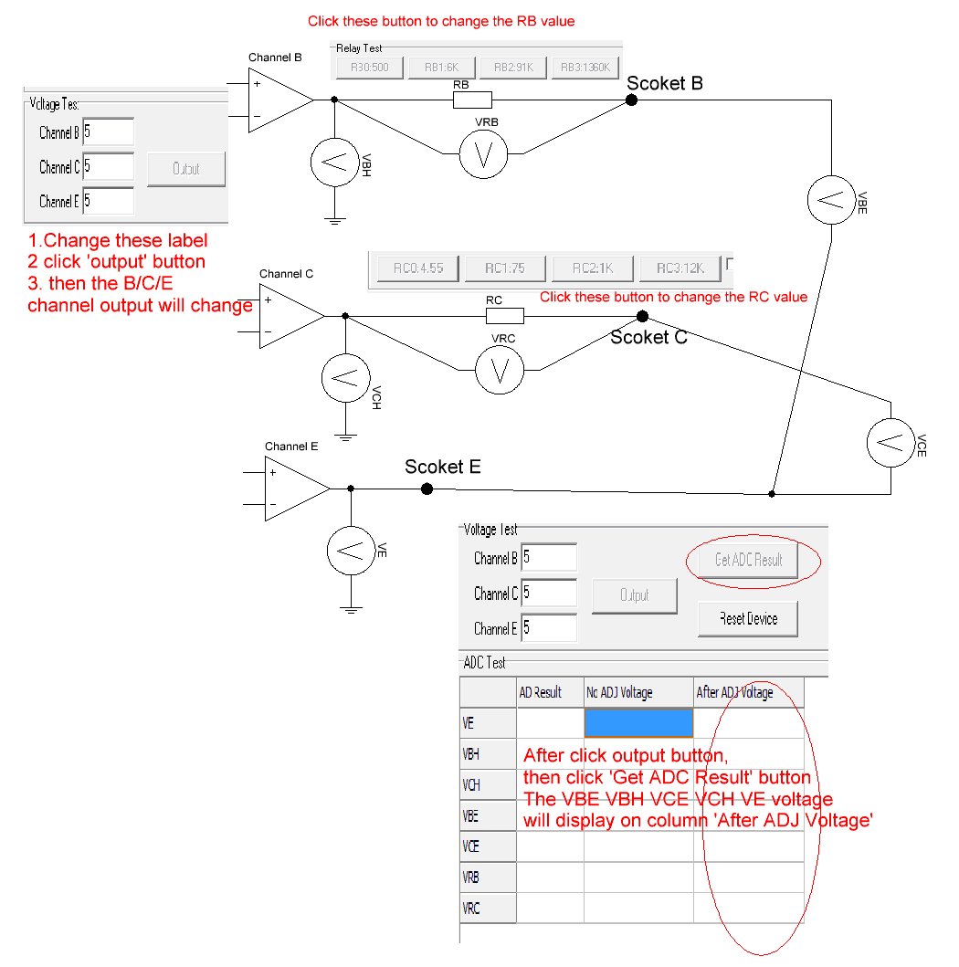
You can set B/C/E label to output different voltage and compare with a DMM(Digital Multi-meter) on “B/C/E socket”. (Pay attention to the DMM input impedance, because B channel may series with a high impedance RB.)
If the voltage measured by multimeter is close your setting voltage, It mean the DAC & power amplifier is OK.

6.Check the system measure voltage is OK?
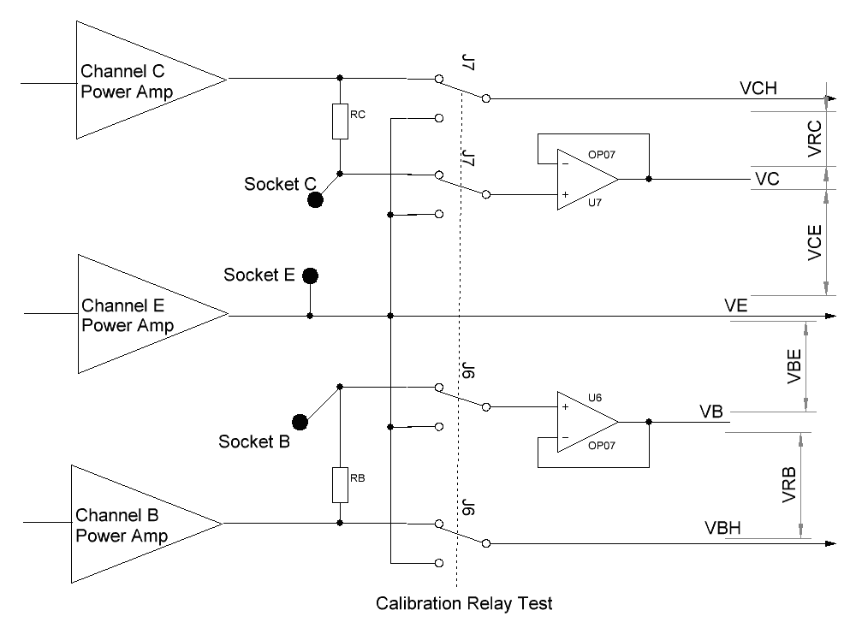
The measurement & calibration circuit as shown above, J6/J7 is calibration relay, They controlled by the checkBox “Calibration relay test”.
Normally the “Calibration relay” selected to B/C channel output, the VE/VCH/VBH value in “After ADJ Voltage” column, they also is close to your B/C/E label setting voltage. The VRB/VRB value in “After ADJ Voltage” column also below 0.02V.
These 7-channel voltages have the following rules:
VBH - VE=VBH+VBE
VCH - VE=VCE+VRC

If you checked the “Calibration Relay Test” checkbox, the J6/J7 will select to E channel output(“VE”), and the “VCH/VC/VB/VBH” all will equal “VE”,and the VCE/VRC/VBE/VRB all will close 0.
By this figure, you can use multimeter to measure the OP07 output (pin 6), and B/C/E socket voltage, compare with the value show in “After ADJ voltage”, you can determine whether U6/U7/J6/J7 is wrong.

Parameter Config
1. System Config
This page parameter store in ads7871_v3s.ini.
“Channel B Power Amp Gain / Channel C Power Amp Gain / Channel E Power Amp Gain” are the three B/C/E channel power amplifier gain, from the schematic diagram, it is 56K/18K +1 = 4.11.
“Voltage Drop (sink)” is the maximum voltage drop of the power amplifier when sink current. In general, set to 2.5V.
“Voltage Drop (source)” is the maximum voltage drop of the power amplifier when output current; generally, it is set to 1.5 to 2V.
“Relay Control” - it is unused, set to Auto.
“ADC Sample Time” - set to default 2 times.
“Language” – set English or Chinese interface. If this option is changed, you need to exit the program and re-run to take effect.

2. ADC Parameters config
This page parameter are store in MCU’s EEPROM, So It no need to change. Unless you get the message “Parameter in EEPROM have some Error!”, If you get “Parameter in EEPROM have some Error!” Please follow the step to re-config the EEPROM parameter:
(1).Set the “ADC Channel Define” as below:
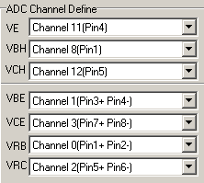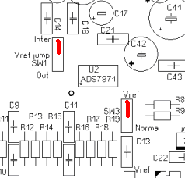
(2). Set the jumper “Vref jump” to "Inter"; jumper SW3 to “Vref”. See red color settings above Figure.
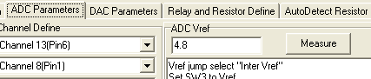
And click button “Measure” in “ADC Vref” GroupBox, Then the system will get the ADC reference voltage.
These jumpers as shown in below circuit:
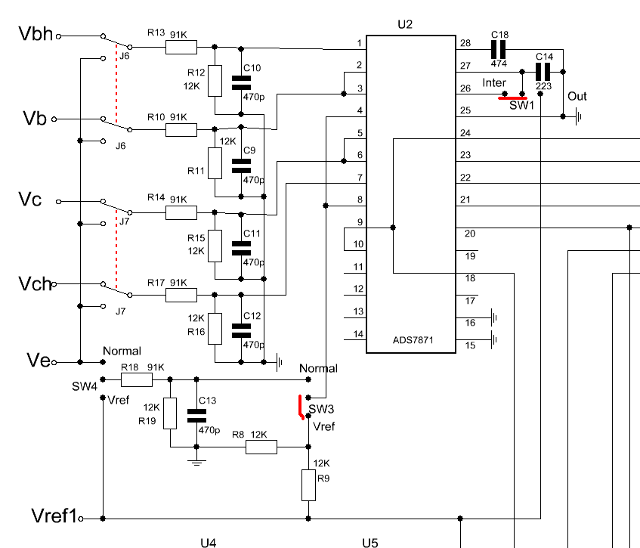
TL431 Vref1 reference voltage pass thought R8/R9 (1/2 voltage divide) and applies to pin 4 of ADS7871 (this channel is to measure the “VE” channel), also, the ADS7871 reference voltage is connected to the ADS7871 internal 2.5V reference voltage. That is, it go through the ads7871 internal reference voltage to measure the reference voltage of TL431, therefore, it is best to choose a higher matching resistor value for R8/R9.
Due to the limitation of ADS7871 “BufOut” output amplitude (Vdd-0.2V), if the measured reference voltage is greater than 4.85V, then, suggests to parallel a resistor to R37, so that the TL431 reference voltage is adjust to about 4.6 ~ 4.8V.

(3). Measure the voltage divider coefficient of ADC
Set "Vref jump" jumper to "Out", Set “SW3” jumper to "Normal", “SW4” jumper to "Vref", as indicated in red color of the Figure.
And click button “Measure” in “ADC Multiple” groupbox, Then the system will get the ADC divider coefficient.

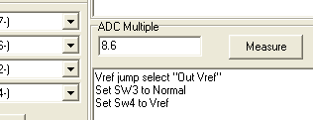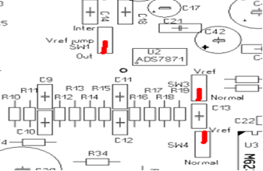
At this point, the circuit wiring is shown in below Figure, the ADS7871's pin4 is connected to the R18 R19 (91K/12K) voltage divider, the voltage divider circuit is connected to the Vref1 reference voltage, in addition, the ADS7871 reference voltage is also connected to Vref1, therefore, by measuring the voltage of Pin 4, system can get the coefficient of R18/R19 voltage divider.
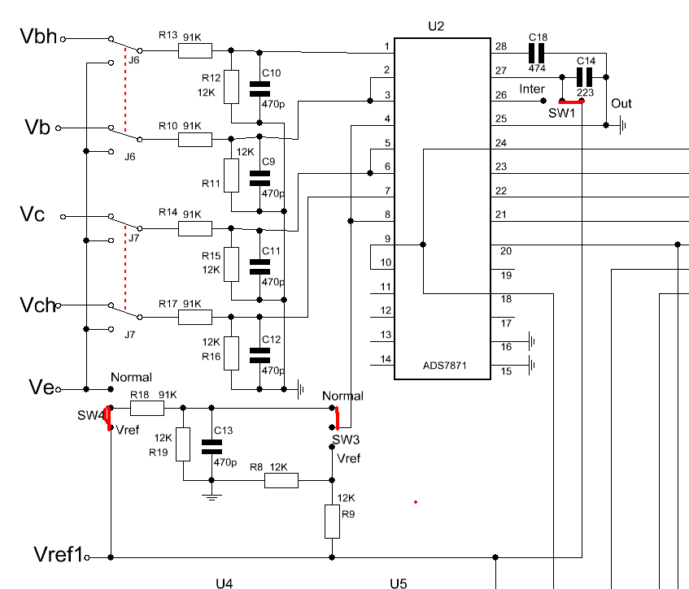
After measured those two parameters, click “Save to EEPROM” button, you will be asked to enter an EEPROM protection password, the password is “ct3”, click ok, the ADC configuration will be saved in EEPROM.

3. DAC configuration parameter
This page parameter are also store in MCU’s EEPROM and no need to change. Unless you get the message “Parameter in EEPROM have some Error!”, If you get “Parameter in EEPROM have some Error!”, please follow the step to re-config the EEPROM parameter:
(1). Set the DAC reference voltage.
Because DAC and ADC share the same reference voltage, simply copy the ADC reference voltage value to the “DAC Vref”. You no need to click “Measure” button.
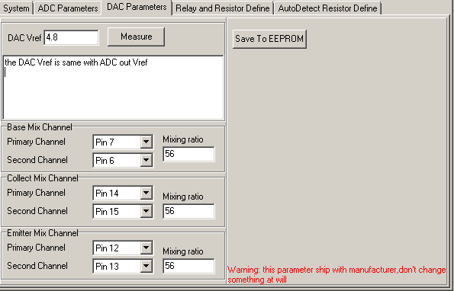
(2). Every two channel DAC combine a high bit DAC with different resistor, Primary channel with 1K resistor, Second channel with 56K resistor, the “mixing ratio” is 56(56k/1K).
The channel assign and “mixing ratio” as above.
If you change the value of R28/R29/R30/R31/R32/R33, you need to modify the mixed ratio.
(3). Click the “save to the EEPROM” and enter the EEPROM password.

4. RB/RC range resistance and control bit settings.
These parameter are store in ads7871_v3s.ini, usually, the b7 ~ b0 settings are as follow figure.
The b7~b0 toggle at “black checked/blank/gray checked”. “Black checked” mean bit=1, “white” mean bit=0, “gray checked” mean it not control this item.
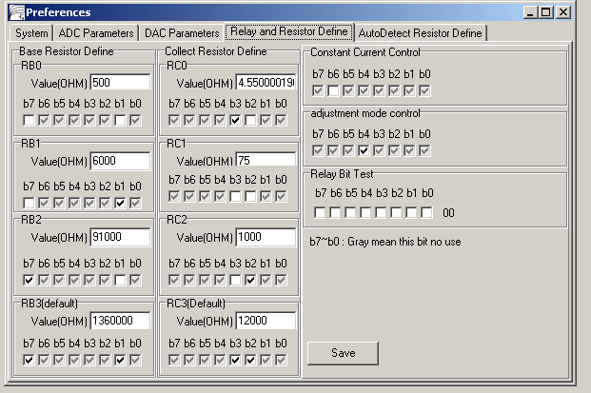 If If you use another value resistor replace the RB/RC resistor, you need to modify the 8 resistances value, and need to do “current Calibration” again.

5. Automatic transistor pin detection and resistor definition and calibration.
This page parameter also stroe in EEPROM. It also no need to re-config it.
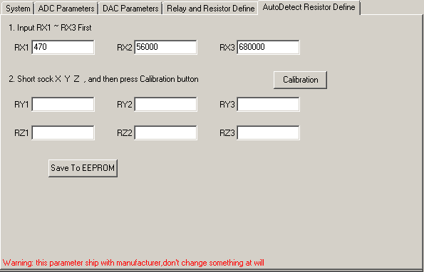
If you want re-config it.
(1). Use some wire to short the three X/Y/Z socket.
(2). Fill the RX1 ~ RX3, they are 470/56000/680000.
(3). Click “Calibration” button, the system will use the X channel resistance to calibration the Y / Z channel resistance. When finish, then click “save to EEPROM”.

6. Restore the jumper to original position.
SW1 Vref jump set to “out” position
SW3 set to the “Normal” position
SW4 set to the “Normal” position
calibration
The calibration includes current and voltage calibration. Voltage calibration must be done first before carry out the current calibration.

The voltage calibration
1. Select Menu “Calibration -> Voltage Calibration”, click the “Begin calibration” button, the system will measure the data, and then click save to the EEPROM, input the eeprom password “ct3”.
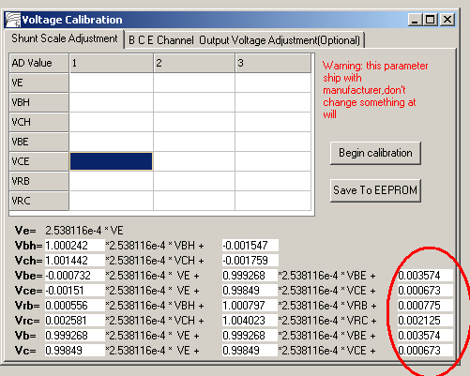

2. Select the page “BCE Channel Output Voltage Adjustment”
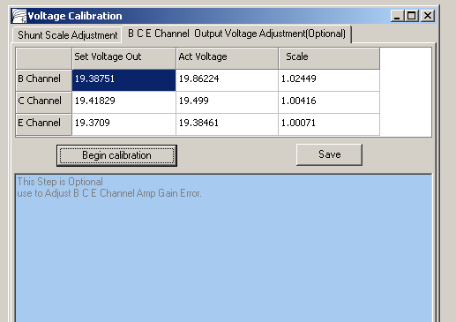
Click “Begin calibration”, the system will set the B/C/E channel amplifier output probably 1/2Vcc, and measure the actual voltage. On the table, the “Act Voltage” column shows the actual voltages measured by ADC. If the voltage is not close to 1/2Vcc, then, there might be some problem on the channel amplifier or DAC, also, the “scale” column values should be close to 1.
Click the “Save” button. The data is stored in the ini file.
After completed the Voltage calibration, you can perform the current calibration.

Current calibration
1. Calibration of each range resistor
Select the menu “Calibration-> the Current Calibration”
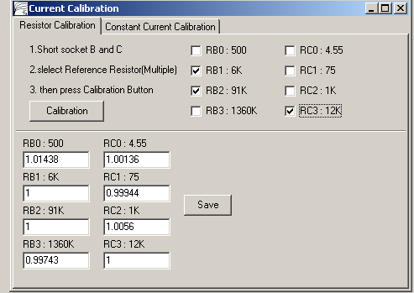

(1). Use a wire connect soctet B and socket C ,
(2). Chose a or more reference resistor. The reference resistor is the most accurate resistors in those 8 resistor. For example, in the board, RC3 = 12K, RB2 = 91K, RB1 = 6K is accurate, then, checked these 3 resistors.
(3). Click “Calibration” button, system will auto set the coefficient of these three resistors(RC3/RB2/RB1) to 1, then, it will use these 3 resistors to calibrate other resistors coefficient.
The calibration diagram is as follows.
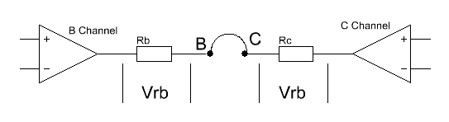
When click “calibration”, system will set B channel amplifier output a maximum voltage and C channel output minimum voltage. Because you use a wire short the scoket B & C, RB and RC is series, the current through them are the same. So it only need to measure the Vrb & Vrc value and know one of resistor value, then, system can calculate another resistor value.
(4).System will automatically control relay to select another resistor and calculate all the coefficient, and then click “Save”. The prameter are saved in .ini file.

2. B Channel constant current module calibration.
(1). Select “Constant Current Calibration” page.
(1). Use a wire to short socket B and socket C, click the “Calibration” button, the system will control the constant-current relay and switch to constant current mode, it will measure the coefficient of the constant current generator. Click “Save” to save data to the ini file.

At this point, all the calibrations were completed.

For those calibration procedures that need to enter eeprom password, in fact, they have been calibrated before shipping out, as such, you do not need to repeat again, unless you replace ADC voltage divider resistors R13 R12 R10 R11 R14 to R15 R17 R16 R18 R19.

